**LAB 4: ACTIVE BAND-PASS FILTER PROJECT**

**ELEC3509 A-L6**

**Name:** Youssef Ibrahim

**Instructor:** Qi-Jun Zhang

**INTODUCTION**

The purpose of this lab is to create a filter using standardized filter blocks. This lab discusses second and fourth order filter circuits also the Chebyshev filter response in the context of a design problem. The design process used in this lab is very similar to the design process used for modern digital filters and transmission line filters.

**THEORY AND DESIGN**

* **Chebyshev Filter Design Requirements**
  1. Band-pass action
  2. Chebyshev response
  3. 3 dB passband ripple
  4. Fourth-order roll-off
  5. Lower cut-off frequency and upper cut-off
  6. Target passband gain = +0.0 dB to -3.0dB
  7. error allowed in
  8. error allowed in passband gain
  9. Supply voltages to be ±15 volts 10
  10. Op-Amps to be type TL082CD (No more than 6 Op-Amps total)
  11. Output voltage swing > ±10 volts
* **Lower Cut-off Frequency**
* **Upper Cut-off Frequency**
* **Bandwidth**
* **Corner Frequency**
* **Quality Factor**
* **Error allowed in**
* **Ripple is**
* **Transfer Function**

The equation below is the general form for the second order 3 dB pass-band ripple Chebyshev filter.

The equation below is the general form for the second order 3 dB pass-band ripple Chebyshev filter in terms of a, b, and c.

By comparing both equation of the second order 3 dB pass-band ripple Chebyshev filter shown above, variables a, b, and c was determined as shown below

The equation shown below is then below is then substituted into the second order filter to transform the second order filter equation to fourth order filter equation.

After substituting the equation above, we end up with the fourth order filter equation as shown below.

After substituting the values of , we get the following equation for the fourth order filter equation as shown below.

The fourth order transfer function shown above consists of two second order transfer functions. In order to find those two second order transfer function , we will need to solve the following equations shown below.

* **MATLAB Simulation for The Overall Chebyshev Filter**

The code used to generate the plot for the overall Chebyshev filter is shown below.

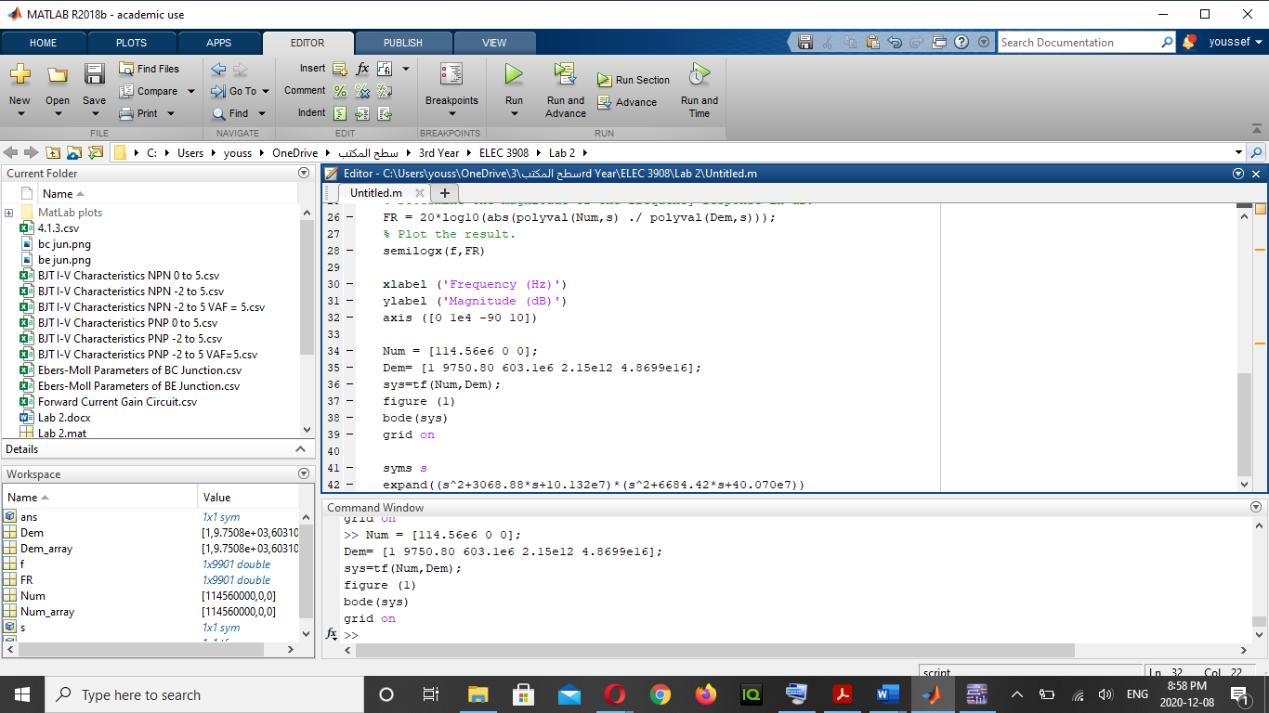

The plot for the overall Chebyshev filter is shown below.

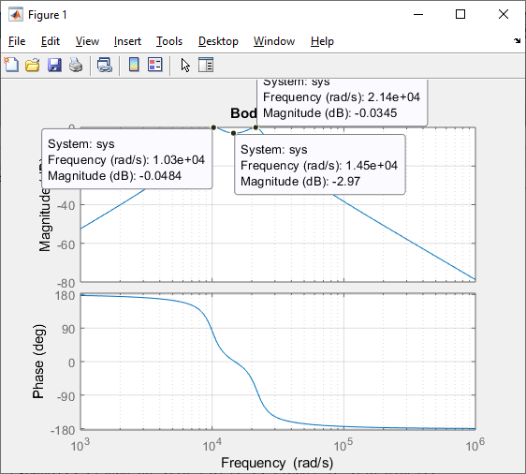

The plot shown above for the Chebyshev filter shows that the center frequency is at 14500 rad/s (2339.6 Hz) and gain is equal to -2.97 dB, is equal to 10300 rad/s (1639.3 Hz), and is equal to 21400 rad/s (3405.9 Hz).

* **MATLAB Simulation for Stage 1 filter**

The code used to generate the plot for the filter is shown below.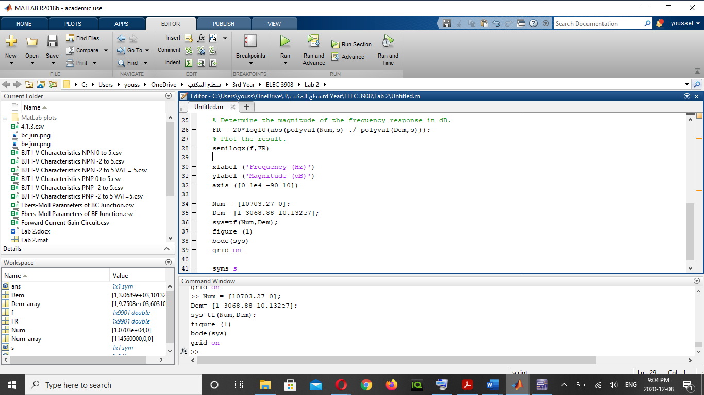

The plot for the filter is shown below.

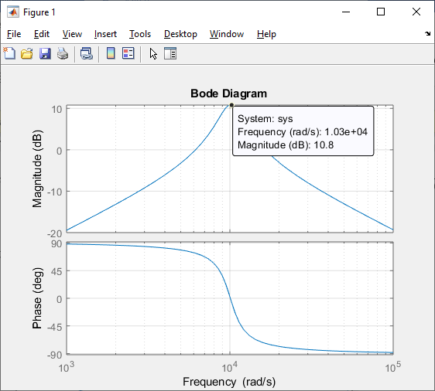

The plot shown above for the Chebyshev filter shows that the center frequency is at 10300 rad/s (1639.3 Hz) and gain is equal to 10.8 dB.

* **MATLAB Simulation for Stage 2 filter**

The code used to generate the plot for the filter is shown below.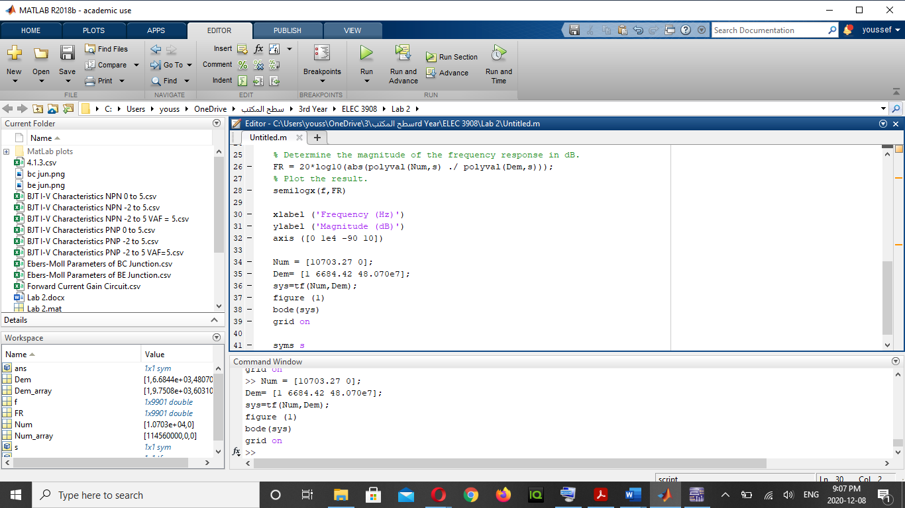

The plot for the filter is shown below.

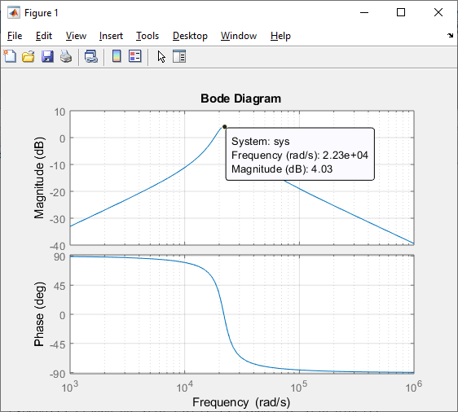

The plot shown above for the Chebyshev filter shows that the center frequency is at 22300 rad/s (3549.2 Hz) and gain is equal to 4.03 dB.

**TOW-THOMAS FILTER**

Shown below is the circuit for Tow-Thomas filter with feedforward.

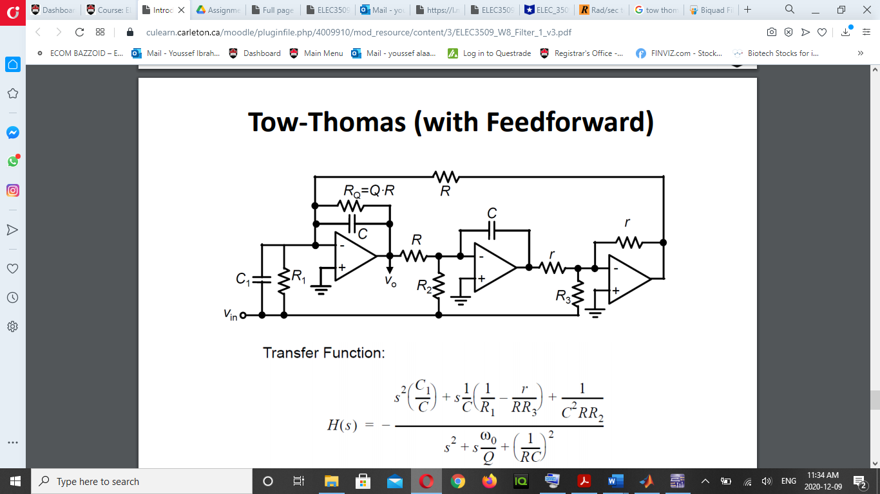

The transfer function for Tow-Thomas (with Feedforward) is shown below.

C, r can be fixed arbitrarily

For Bandpass: . Hence, the bandpass Tow-Thomas filter can be represented as shown below.

* **First Stage**
  + Center Frequency
  + Bandwidth
  + Quality Factor
  + Theoretical Gain
  + Capacitance Value
  + Resistance Values
* **Second Stage**
  + Center Frequency
  + Bandwidth
  + Quality Factor
  + Theoretical Gain
  + Capacitance Value
  + Resistance Values

**TOW-THOMAS SIMULATION**

* **First Stage** 
  + **Simulation using Theoritical Values**

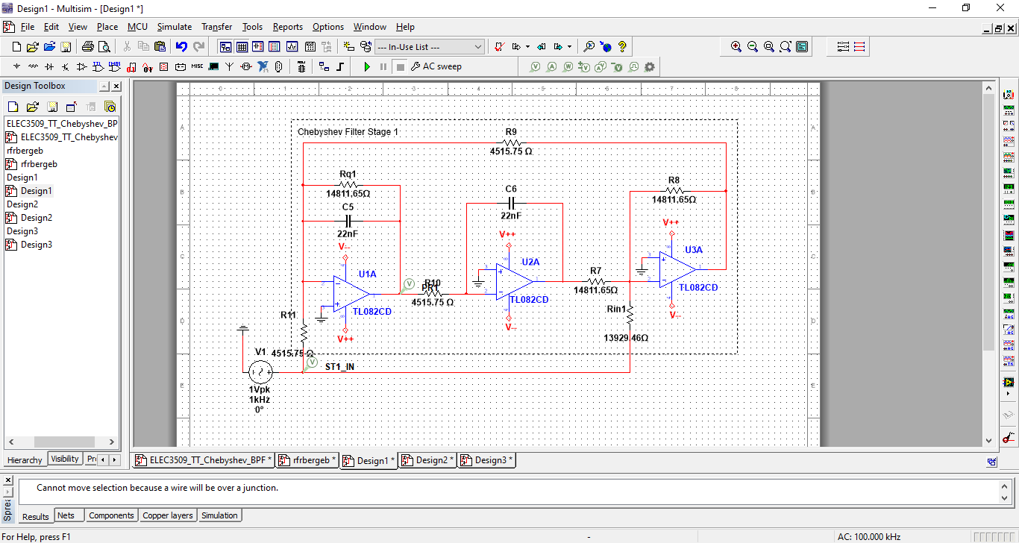

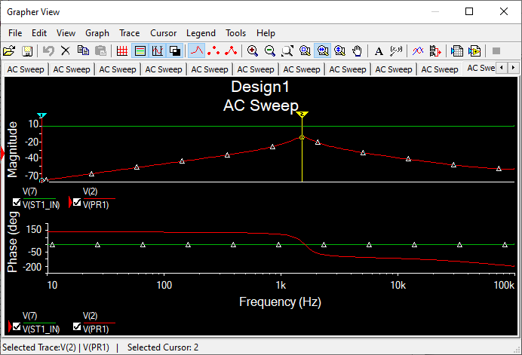

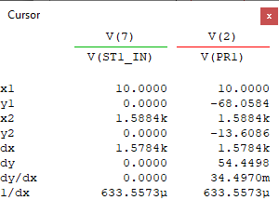

Center frequency is at 1588.4 Hz (9980.2rad/s), and Gain is -13.6086 dB.

* + **Simulation using Standard Values**

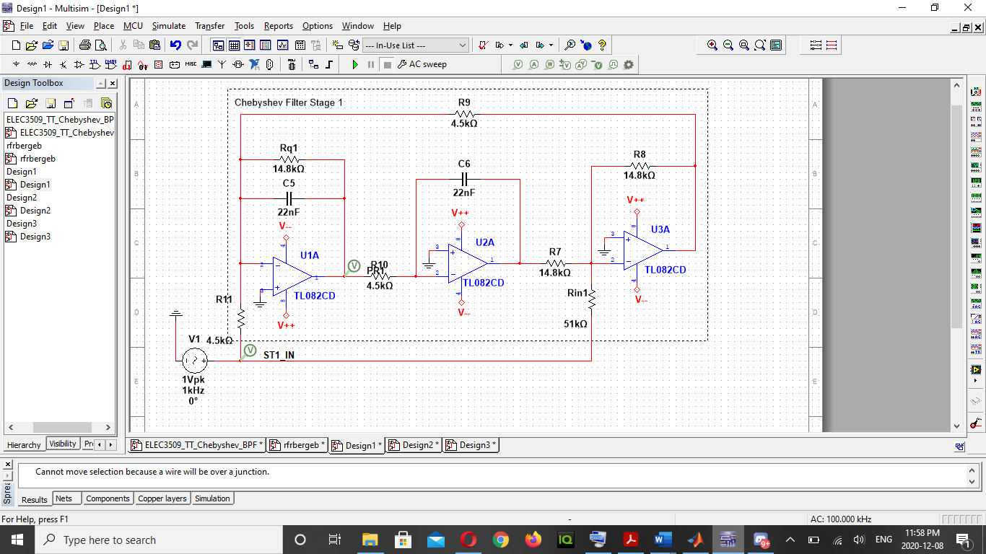

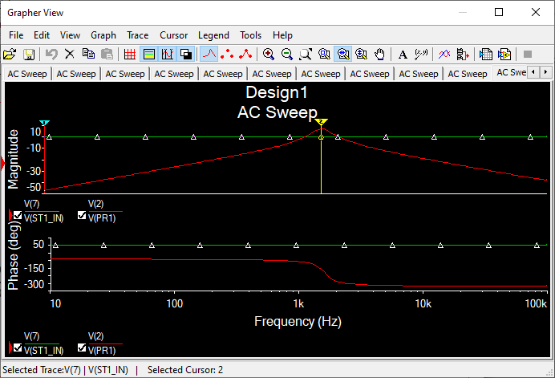

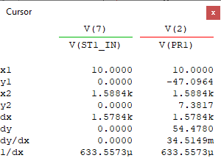

Center frequency is at 1588.4 Hz (9980.2 rad/s), and Gain is 7.3817 dB.

* **Second Stage** 
  + **Simulation using Theoritical Values**

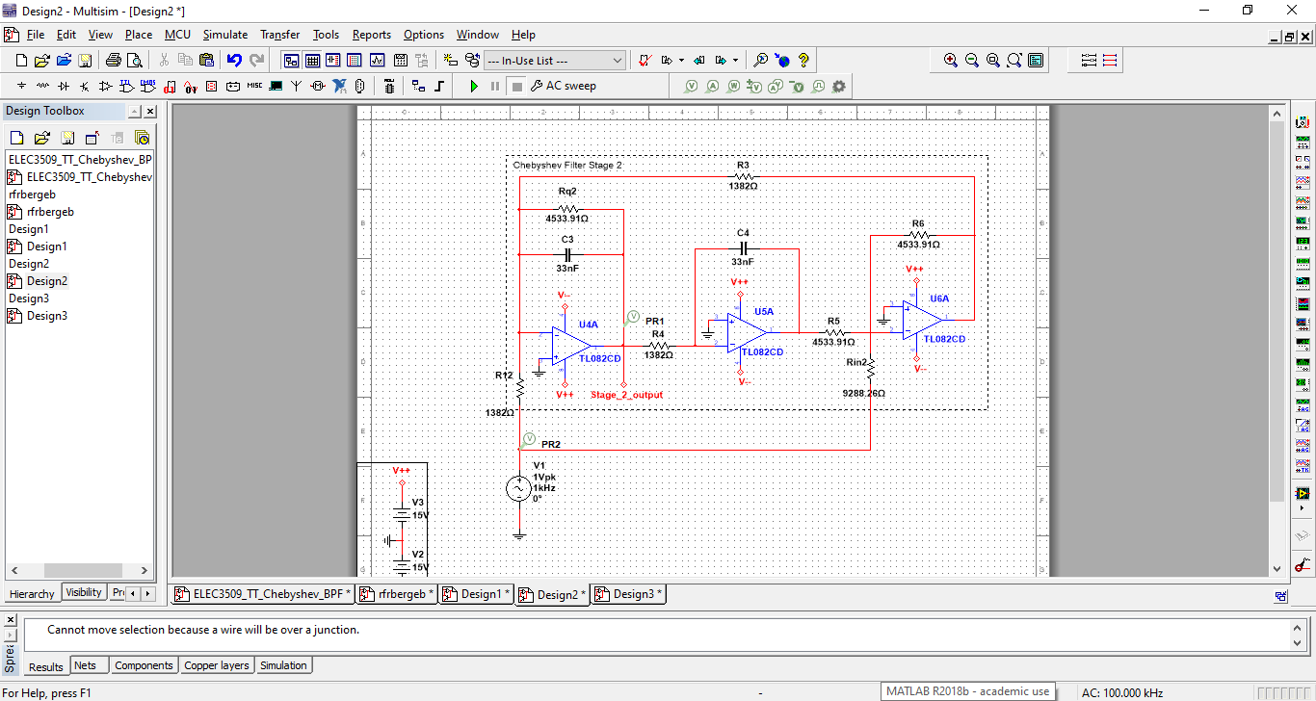

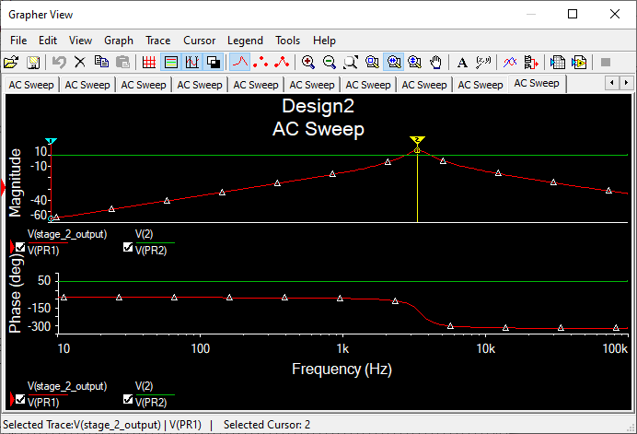

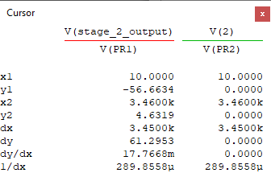

Center frequency is at 3460 Hz (21739.8 rad/s), and Gain is 4.6319 dB.

* + **Simulation using Standard Values**

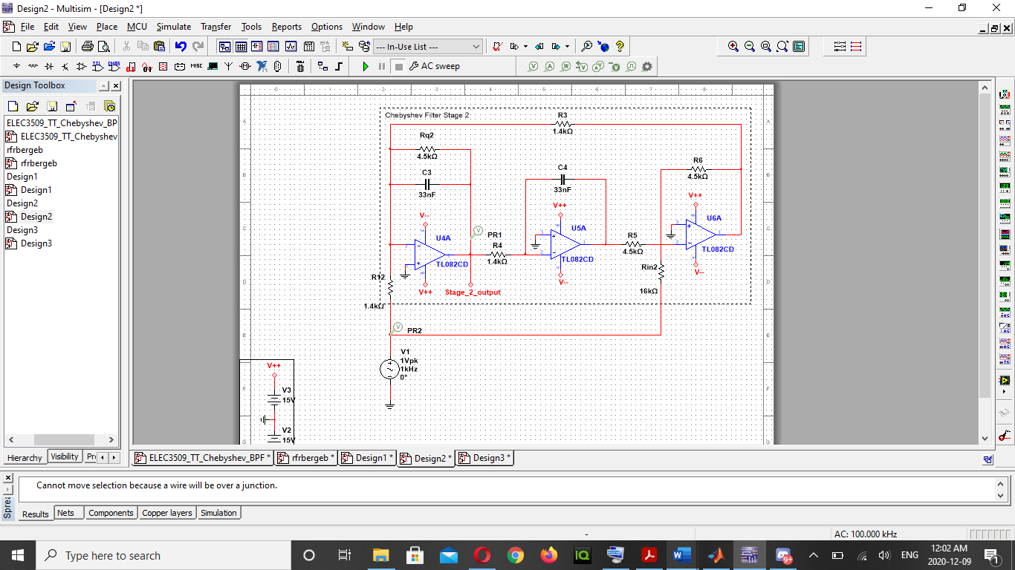

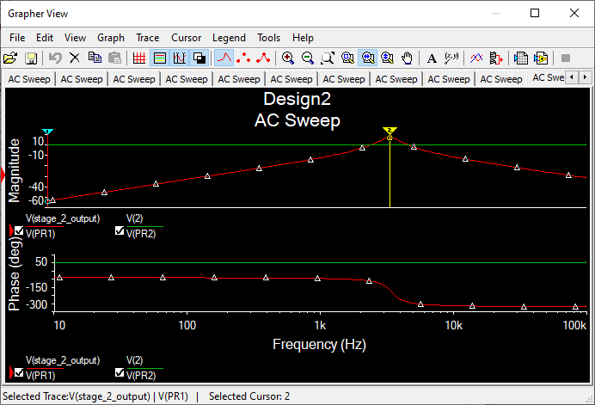

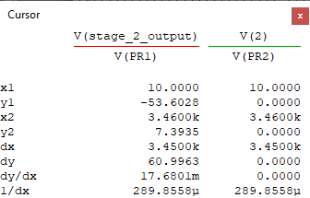

Center frequency is at 3460 Hz (21739.8 rad/s), and Gain is 7.3935 dB.

* **Full Chebyshev Filter** 
  + **Simulation using Theoritical Values**

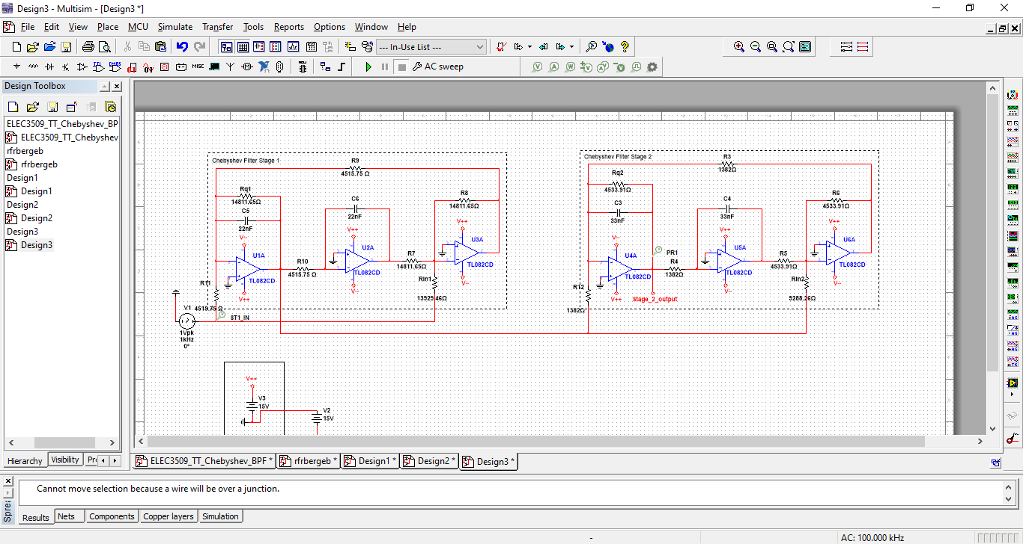

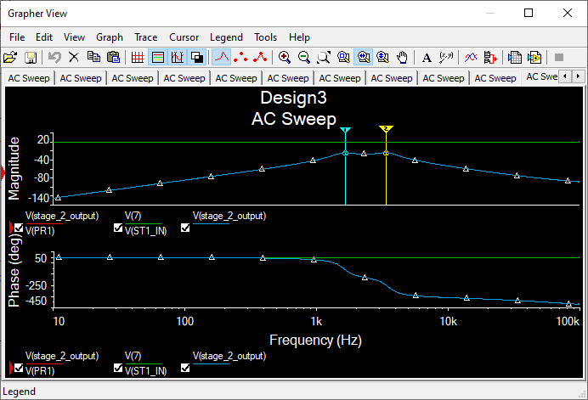

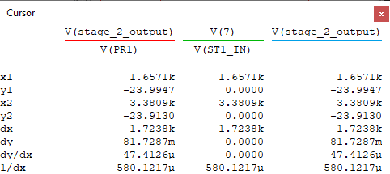

The Full Chebyshev filter has a lower -3db frequency equals to 1657.1 Hz (10411.8 rad/s), and upper -3dB frequency equals to 3380.9 Hz (21242.8 rad/s).

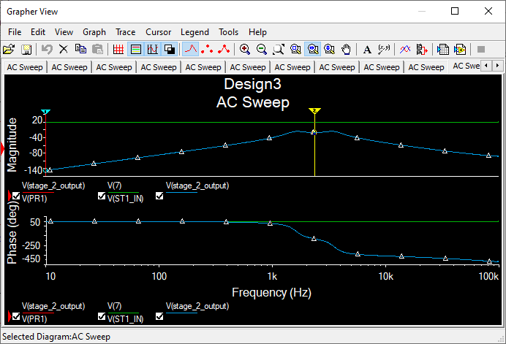

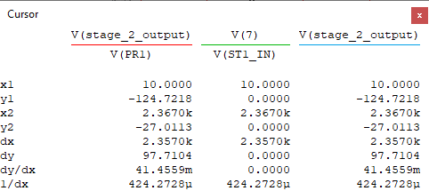

The Full Chebyshev filter has a gain of -27.0113 dB and center frequency equal to 2367 Hz (14872.3).

* + **Simulation using Standard Values**

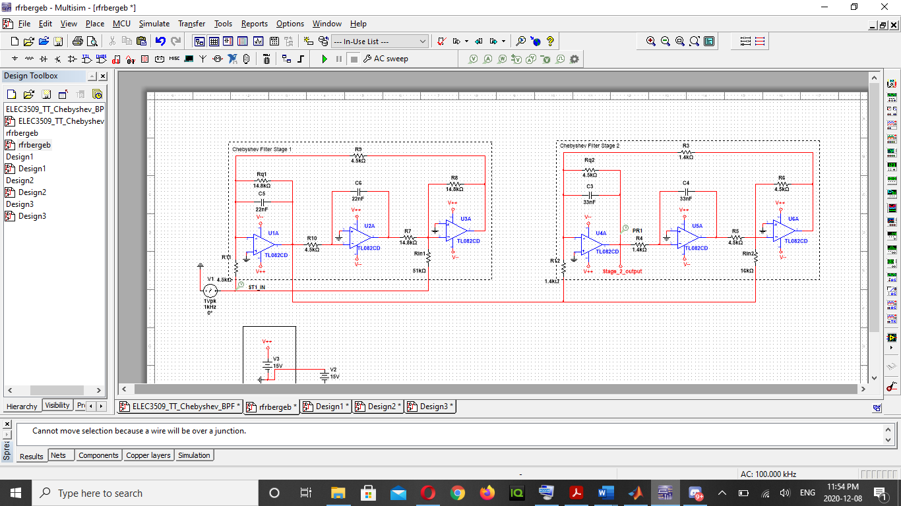

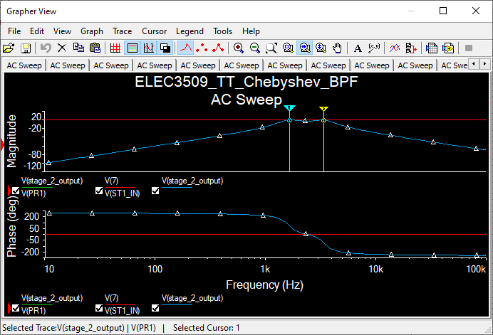

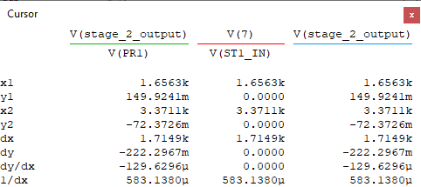

The Full Chebyshev filter has a lower -3db frequency equals to 1656.3 Hz (10406.8 rad/s), and upper -3dB frequency equals to 3371.1 Hz (21181.2 rad/s).

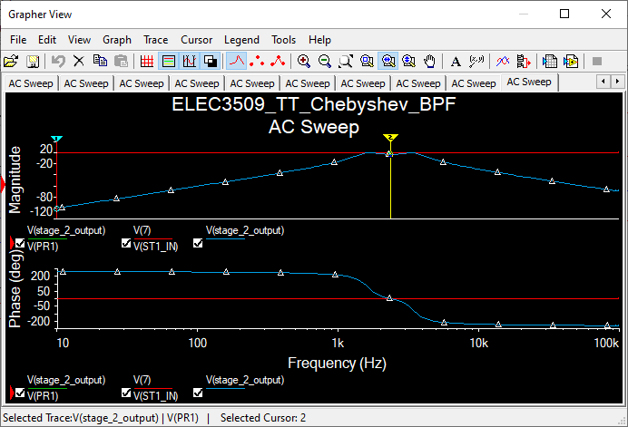

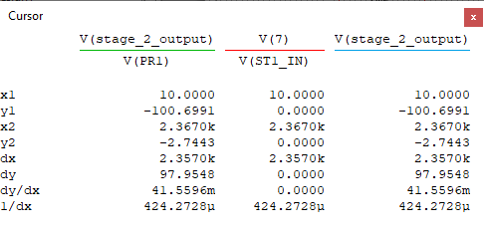

The Full Chebyshev filter has a gain of -2.7443 dB and center frequency equal to 2367 Hz (14872.3 rad/s).

The table below show the theoretical and standard values for the different resistors used in the simulation.

|  |  |  |
| --- | --- | --- |
| **Resistor** | **Theoretical Value** | **Standard Value** |
|  | 4515.75 | 4500 |
|  | 14811.65 | 14800 |
|  | 14811.65 | 14800 |
|  | 13929.46 | 51000 |
|  | 1382 | 1400 |
|  | 4533.91 | 4500 |
|  | 4533.91 | 4500 |
|  | 9288.26 | 16000 |

**KHN FILTER**

Shown below is the circuit for KHN filter.

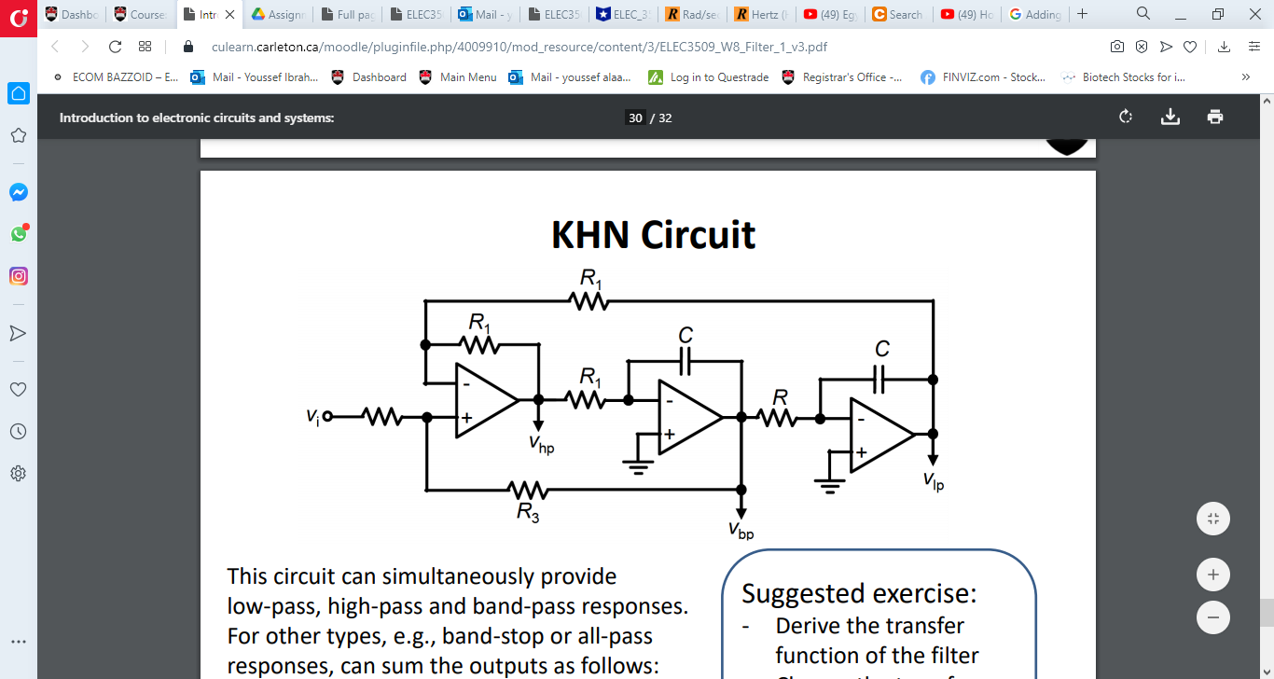

The transfer function for KHN filter is shown below.

* **First Stage**
  + Center Frequency
  + Bandwidth
  + Quality Factor
  + Capacitance Value
  + Resistance Values
* **Second Stage**
  + Center Frequency
  + Bandwidth
  + Quality Factor
  + Capacitance Value
  + Resistance Values

**KHN SIMULATION**

* **First Stage**

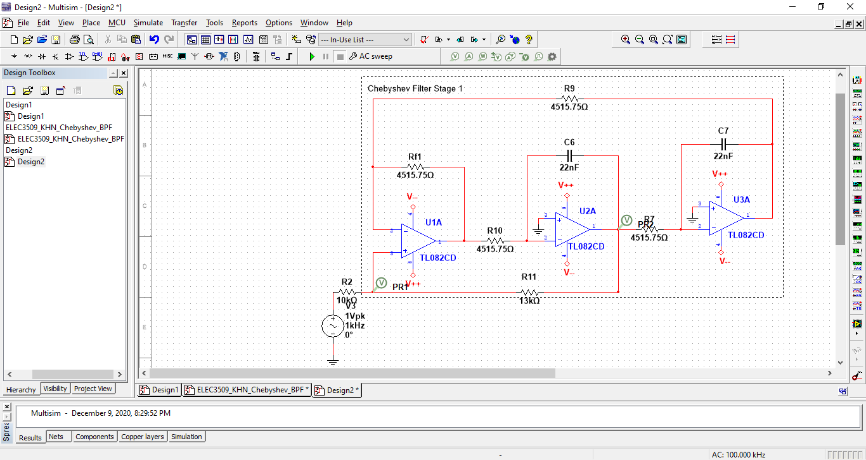

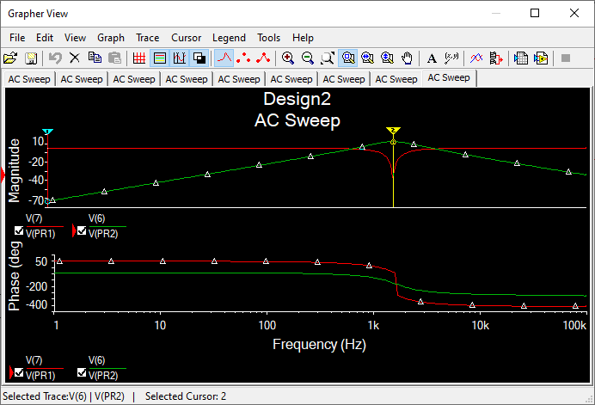

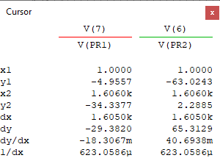

Center frequency is at 1606 Hz (10090.8 rad/s), and Gain is 2.2885 dB

* **Second Stage**

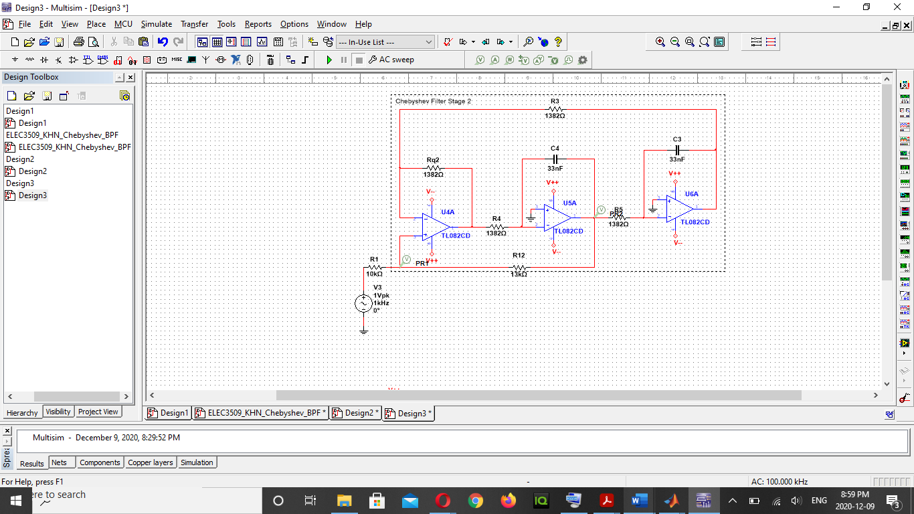

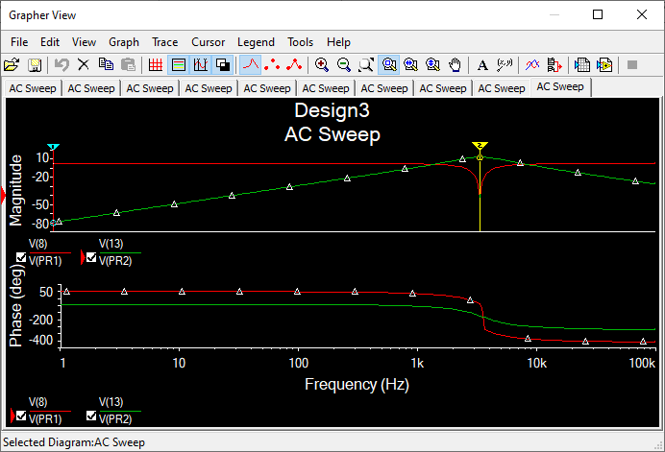

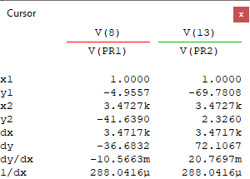

Center frequency is at 3471.7 Hz (21809.5 rad/s), and Gain is 2.326 dB

* **Overall KHN Filter**

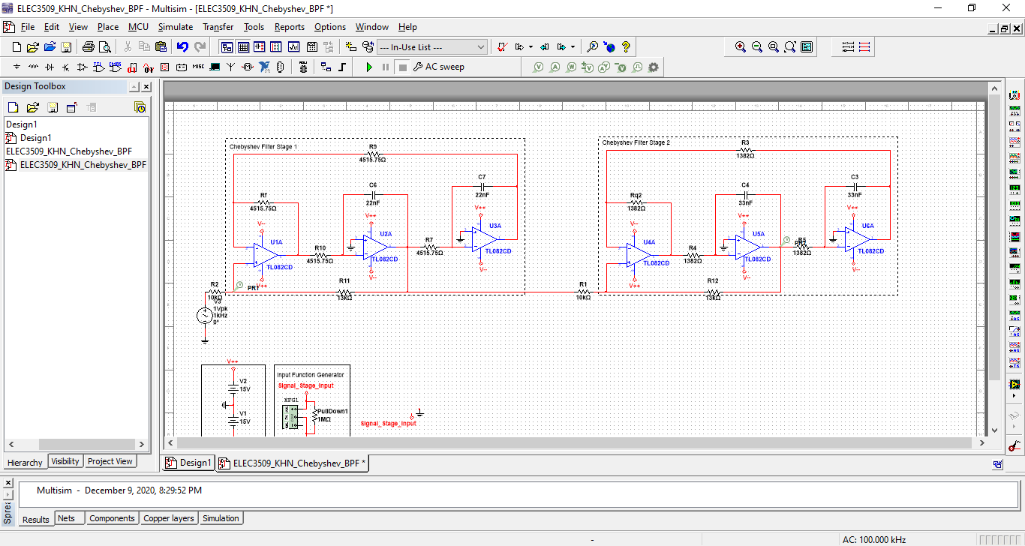

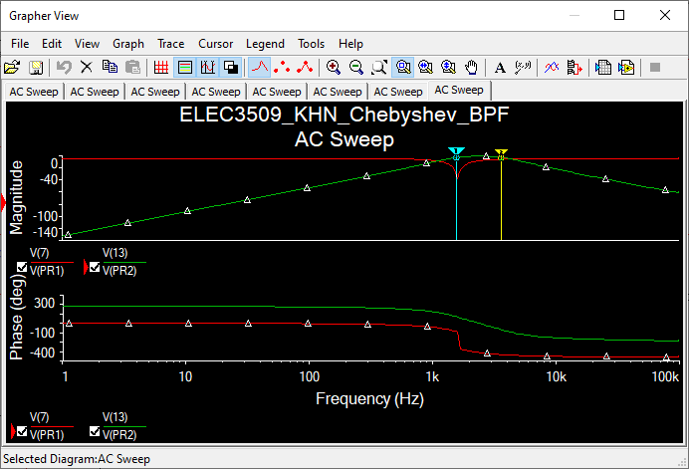

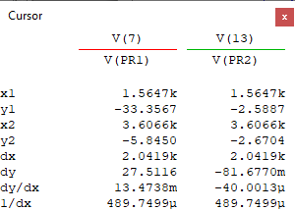

The overall filter has a lower -3db frequency equals to 1564.7 Hz (9831.3 rad/s), and upper -3dB frequency equals to 3606.6 Hz (22660.9 rad/s).

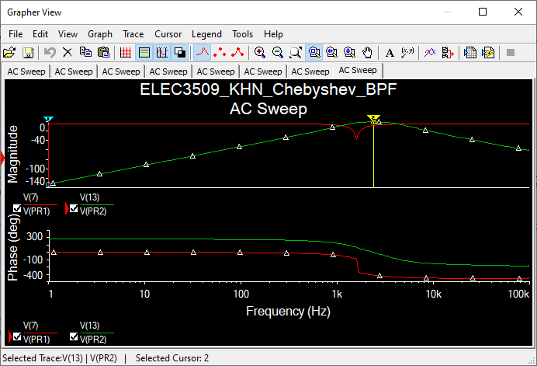

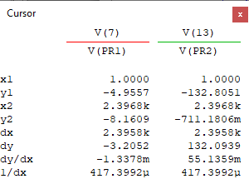

The overall filter has a gain of -0.711 dB and center frequency equal to 2369.8 Hz (14889.9 rad/s).

**RESULTS**

The table below shows the theoretical, simulated, and simulated standard values for the for the stage 1 filter circuit.

|  |  |  |  |  |  |
| --- | --- | --- | --- | --- | --- |
|  | **Prelab** | **Matlab** | **Simulated TT** | **Simulated Standard TT** | **Simulated KHN** |
|  | 10.8 dB | 10.8 dB | -13.6086 dB | 7.3817 dB | 2.2885 Db |
|  | 10065.784 rad/s | 10300 rad/s | 9980.2 rad/s | 9980.2 rad/s | 10090.8 rad/s |

The table below shows the theoretical, simulated, and simulated standard values for the for the stage 2 filter circuit.

|  |  |  |  |  |  |
| --- | --- | --- | --- | --- | --- |
|  | **Prelab** | **Matlab** | **Simulated TT** | **Simulated Standard TT** | **Simulated KHN** |
|  | 4.03 dB | 4.03 dB | 4.6319 dB | 7.3935 dB | 2.326 dB |
|  | 21925 rad/s | 22300 rad/s | 21739.8 rad/s | 21739.8 rad/s | 21809.5 rad/s |

The table below shows the theoretical, simulated, and simulated standard values for the for the overall filter circuit.

|  |  |  |  |  |  |
| --- | --- | --- | --- | --- | --- |
|  | **Prelab** | **Matlab** | **Simulated TT** | **Simulated Standard TT** | **Simulated KHN** |
|  | -2.97 dB | -2.97 Db | -27.0113 dB | -2.7443 dB | -0.711 dB |
|  | 3856.04 Hz | 3405.9 Hz | 3380.9 Hz | 3371.1 Hz | 3606 Hz |
|  | 1449.64 Hz | 1639.3 Hz | 1657.1 Hz | 1656.3 Hz | 1564.7 Hz |
|  | 15119.87 rad/s | 11099.88 rad/s | 10830.95 rad/s | 10774.41 rad/s | 12825.87 rad/s |
|  | 14855.28 rad/s | 14846.53 rad/s | 14872.03 rad/s | 14846.88 rad/s | 14924.79 rad/s |

**ANALYSIS**

In the overall filter circuits, The Simulated Standard Tow-Thomas, Matlab, and Simulated KHN achieved a suitable gain of -2.7443dB, -2.97 dB, and -0.711 dB, while the Simulated Tow-Thomas using the theoretical values achieved a non-acceptable gain of -27 dB so I had to change some resistor values in the Simulated Standard Tow-Thomas simulation until I got an acceptable gain. All simulations using Matlab, Theoretical Simulation of TT, Simulated Standard TT, and Simulated KHN achieved an upper and lower 3-db frequency within the range specified in the prelab which is from 1449.64 Hz to 3856.04 Hz. Also, all simulations using Matlab, Theoretical Simulation of TT, Simulated Standard TT, and Simulated KHN achieved a bandwidth and center frequency which is relatively close to each other.

For the first and second stage filter circuit, the Matlab, Simulated TT, Simulated Standard TT, and Simulated KHN achieved a center frequency which is relatively close to the prelab’s center frequency which is 10065.784 rad/s and 21925 rad/s respectively.

For the first stage filter circuit the Matlab, Simulated TT, Simulated Standard TT, and Simulated KHN achieved a gain of 10.8 dB, -13.61 dB, 7.382 dB, 2.229 dB, Matlab simulation was the only simulation to be close to the prelab’s value while the rest of the simulations had a value which was relatively different to that of the prelab..

For the second stage filter circuit the Matlab, Simulated TT, Simulated Standard TT, and Simulated KHN achieved a gain of 4.03 dB, 4.63 dB, 7.39 dB, 2.33 dB which are all unacceptable except for the gain produced by Matlab and the Simulated KHN which are close to the prelab’s value 4.03 dB.

**CONCLUSION**

In conclusion, the purpose of this lab was successfully achieved, also I can conclude that the Tow-Thomas filter is better and easier to build compared to the KHN filter to construct a Chebyshev filters.